
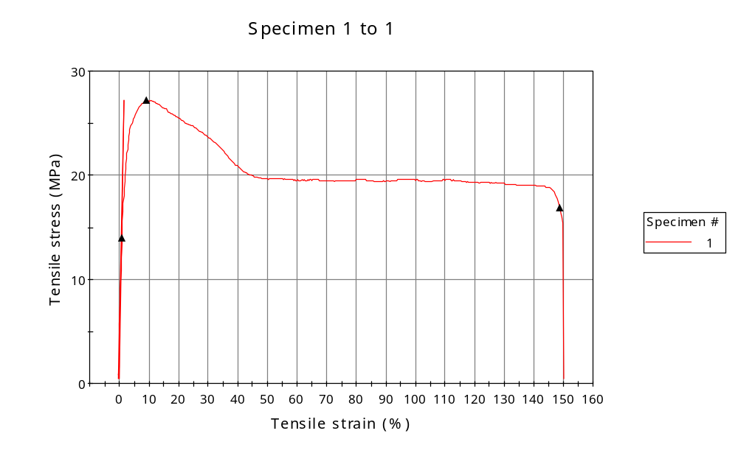
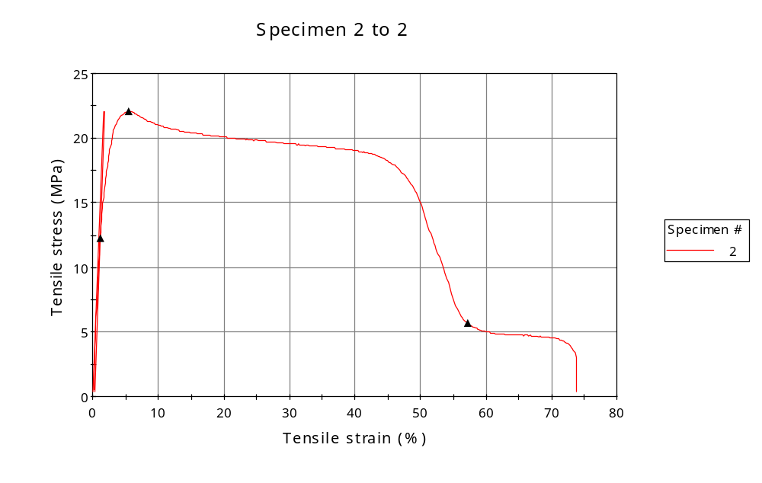
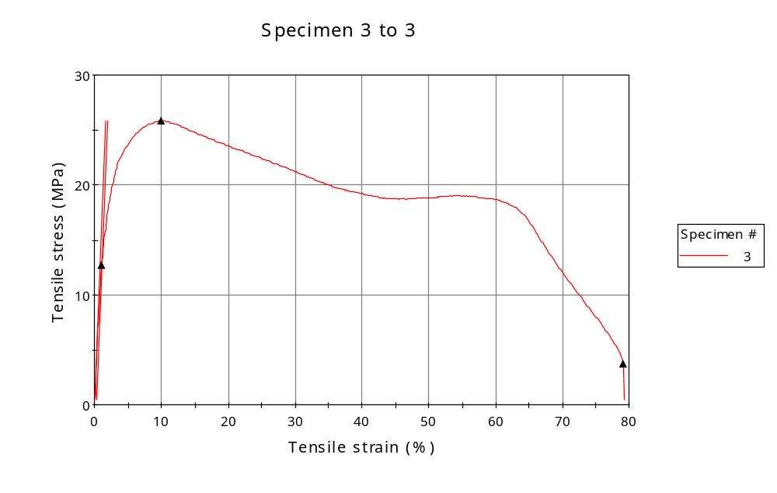
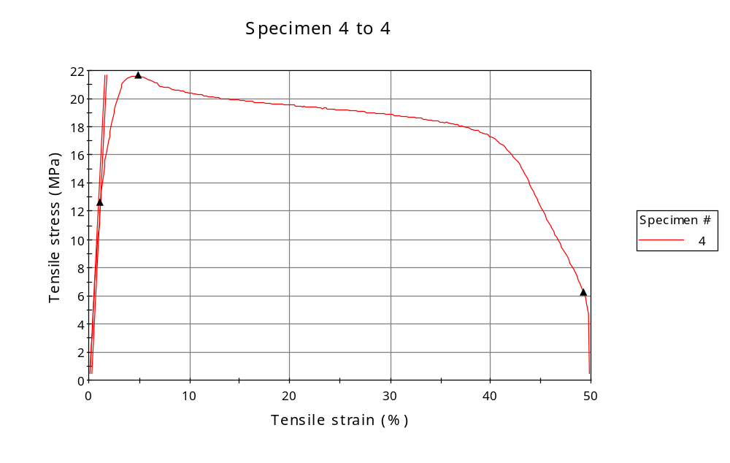
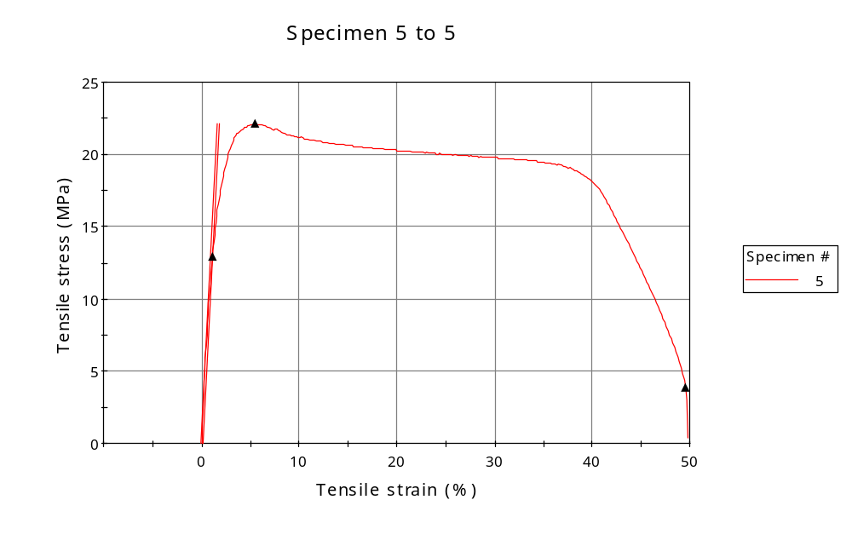
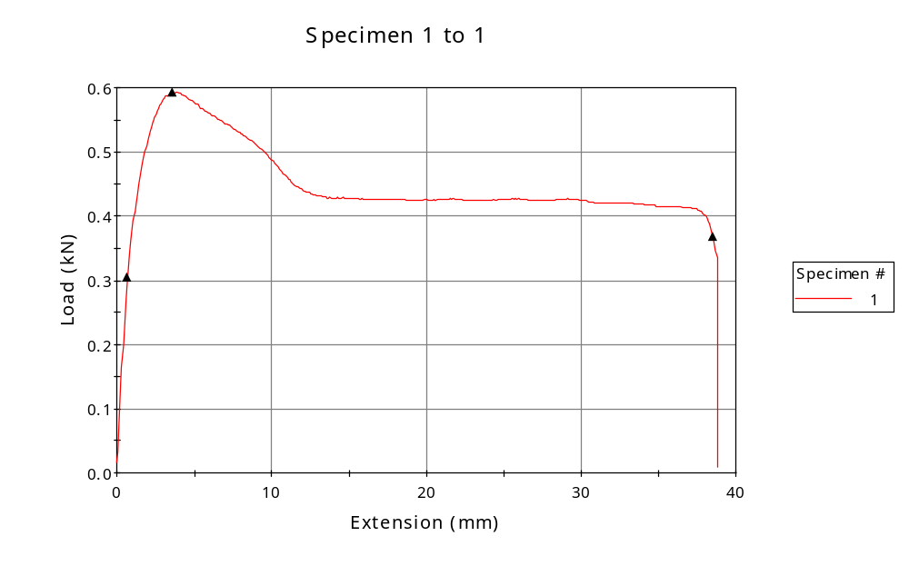
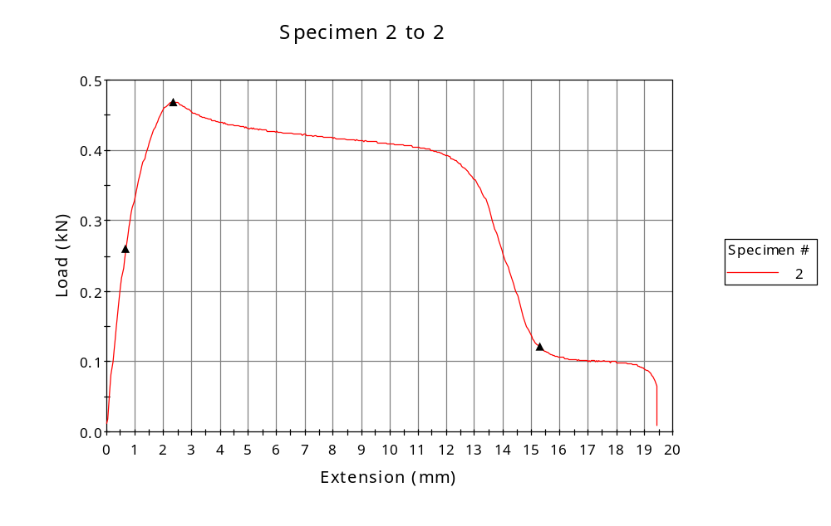
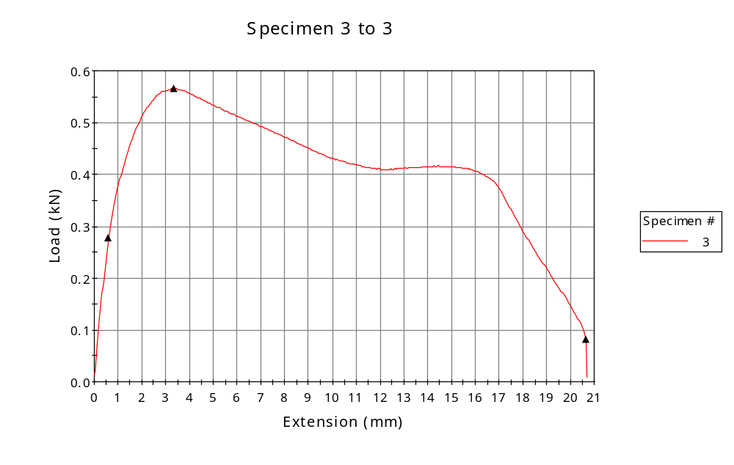
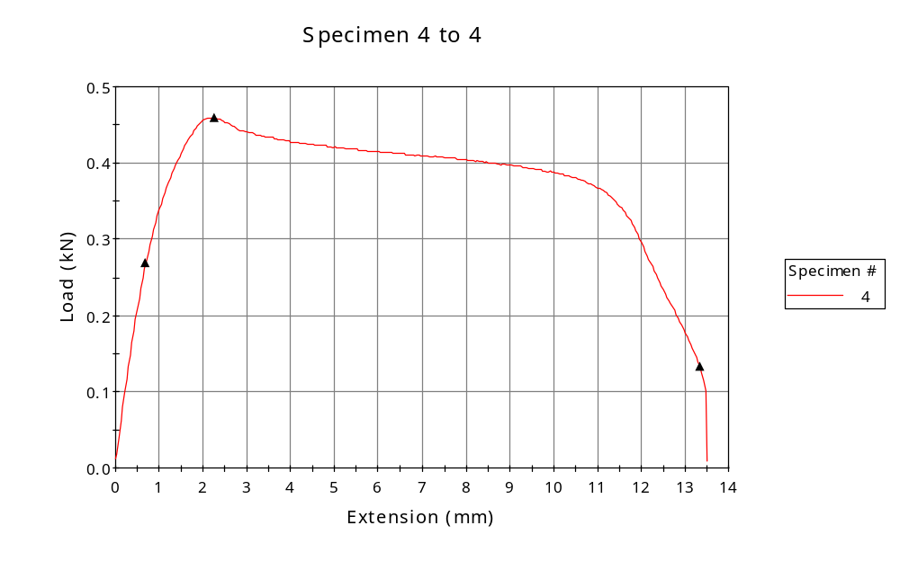
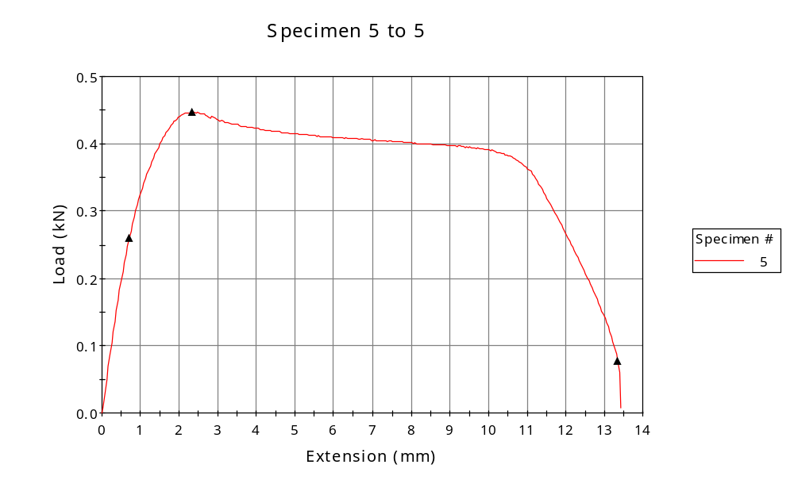

 | CP ID | Length  (mm) | Width  (mm) | Thickness  (mm) | Modulus (Automatic Young's)  (MPa)
1 | CP-PP_02 | 25.00 | 7.27 | 3.00 | 1510
2 | CP-PP_03 | 25.00 | 7.08 | 3.00 | 1379
3 | CP-PP_04 | 25.00 | 7.30 | 3.00 | 1543
4 | CP-PP_05 | 25.00 | 7.08 | 3.00 | 1421
5 | CP-PP_06 | 25.00 | 6.74 | 3.00 | 1375
Maximum |  | 25.00 | 7.30 | 3.00 | 1543
Minimum |  | 25.00 | 6.74 | 3.00 | 1375

 | Load at Fy ( 0.2 %) - LE  (kN) | Tensao em Fy ( 0.2 %) - LE  (MPa) | Deformacao em Fy ( 0.2 %) - LE  (%) | Forca Max  (kN) | Tensao na Forca Max - LR  (MPa)
1 | 0.305 | 14 | 0.761 | 0.593 | 27
2 | 0.260 | 12 | 1.126 | 0.469 | 22
3 | 0.278 | 13 | 1.045 | 0.565 | 26
4 | 0.268 | 13 | 1.158 | 0.460 | 22
5 | 0.260 | 13 | 1.111 | 0.447 | 22
Maximum | 0.305 | 14 | 1.158 | 0.593 | 27
Minimum | 0.260 | 12 | 0.761 | 0.447 | 22

 | Deformacao na Forca Max - LR  (%) | Forca na Forca na Quebra - LQ  (kN) | Deformacao na Forca na Quebra - LQ  (%) | Final length  (mm) | Final width  (mm)
1 | 9.273 | 0.367 | 148.939 | 119.00 | 6.82
2 | 5.543 | 0.120 | 57.209 | 119.00 | 6.82
3 | 10.003 | 0.082 | 79.170 | 119.00 | 6.82
4 | 4.905 | 0.132 | 49.238 | 119.00 | 6.82
5 | 5.555 | 0.078 | 49.554 | 119.00 | 6.82
Maximum | 10.003 | 0.367 | 148.939 | 119.00 | 6.82
Minimum | 4.905 | 0.078 | 49.238 | 119.00 | 6.82

 | Alongamento
1 | 3.76
2 | 3.76
3 | 3.76
4 | 3.76
5 | 3.76
Maximum | 3.76
Minimum | 3.76

